# **Junior Research Lab: Pasta la Vista**

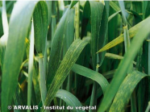

# **Registered Report:** A relationship between soil characteristics and depth with the quantity of *P. graminis* resting spores.

Bijl Indira, Gorius Ava, Rasool Mujahid, Rossetti Gabriela

Institut SupAgro Montpellier

## Abstract

We will be analyzing the correlation between soil characteristics (including pH, water content, texture, organic matter content, bulk density) and depth to the prevalence of resting spores of the protist *P. graminis* which is a vector for *Wheat Spindle Streak Mosaic Virus* (WSSMV). This virus has detrimental effects on the wheat yield all over the world. We developed a method to detect both the presence and quantity of *P. graminis* in the soil using PCR and RT-PCR while comparing it to microscope analysis. Using the spore and soil relationships, we want to characterize the infectious potential to help farmers in the future to detect the fungus in their soil before planting. Our hypothesis is that soils with low bulk density and water content, high organic matter with a sandier texture will have the least amount of resting spores and an overall low infectious potential.

## Introduction

*Polymyxa graminis*, classified under the order Plasmodiophorales, is a biotrophic eukaryote that parasites the roots of wheat and other cereals. (Delfosse P. et al, 2000, Kanyuka et al, 2003). It is not considered a pathogen by itself since it does not cause any detrimental effects on the host plant (Tyagi S et al, 2016). However, *P. graminis* has been reported as the vector for a soil borne virus called *Wheat Spindle Streak Mosaic Virus* (WSSMV) which leads to the host's infection (Tyagi S et al, 2016; Driskel et al. 2004; ). The virus is pathogenic and causes a substantial reduction in the yield of wheat (Kayim et al., 2022). Due to the life cycle of this protist, chemical control of these diseases is not efficient or acceptable in most stances due to economic and ecological reasons (Tyagi S et al, 2016). Therefore, alternative methods of identifying and controlling this disease are needed. One of the controversies surrounding this topic is the inability to tell whether the resting spores are infected or not with the virus since they can survive in soil for up to 20 years if the environment stays suitable (Kunyuka et al, 2003). Once water is added to the environment, these resting spores germinate and grow their bi-flagellate along with the ability to swim and infect new young, susceptible plants. These newly germinated zoospores are dependent on both porosity of the soil and its moisture content for transmitting the diseases (Adams, 1990). There are many factors, the characteristics of the soil (OM content, porosity, water content etc) and depth, that contribute to the viability and movement of the resting spores. One example is the organic carbon content. A study was done by Du et al (2022) comparing fertilizers and organic carbon content and they found that phytopathogens were strongly correlated to the diversity and relative abundance of fungal phytopathogens in agricultural soils. As the organic carbon content in the soil increased, so did the abundance and diversity of the fungal phytopathogens in the soil (Du et al, 2022). Another factor that can influence the presence of resting spores on the soil is its correlation with depth which Cranmer, Travis J., et al. (2017) noted regarding other microorganisms with a similar life cycle. Their results indicated that the resting spores move downwards in the soil profile overtime, machinery and tillage can also affect the depth of the pathogen spread. Workneh et al (1998) found significant differences in the depth reached by the fungus *P. sojae* when comparing tillage techniques: no-till; closer to the soil, tillage; deeper. From their observations of the *P. brassicae* resting spores, they were found within 20 cm of the surface, but each site had significant differences between sites due to the influence of the soil structure (Cranmar, Travis J., et al., 2017; Workneh et al. 1998). The objective of this study is to conduct ELISA tests, microscope detection, PCR, RT-PCR on *P. graminis* to be able to detect and quantify its presence in the soil and find correlations between soil pH, bulk density, water content, organic matter content, texture and depth with the spores prevalence. The ability to be able to detect resting spores in the soil will be important since we can categorize the amount of resting spores and connect it to the infectious potential. The infectious potential of the soil will allow for farmers to test before planting to detect how infectious their soil is for the next planting season to see if they should plant there or not. We will also be closing the knowledge gap between the resting spores and their presence in the soil.

## Methods

### Soil sampling

At the field site, soil samples will be taken from 4 different locations in the infected field, according to figure X. These four locations are based on a nested sampling scheme, using visual features in the field to distinguish between the 4 sample locations. Location 1 is determined by the visual detection of the virus in the wheat crops. Location 2 is at the start of a waterway in the field, where the resting spores are thought to be able to swim an unknown distance to spread through the soil. Location 3 is at the end of the water way, in an visually uninfected area. Finally, location 4 is also in a visually uninfected area. Within these sample locations, a random sampling scheme will be used to take 2 soil sample replicates for bulk density and soil moisture content, and 2 composite soil samples for pH, organic matter content, and texture.

Next to the samples for soil characterization, samples will be taken at three different depths (0-20, 20-40, 40-60 cm). This is based on general characteristics of wheat root concentrations (source)

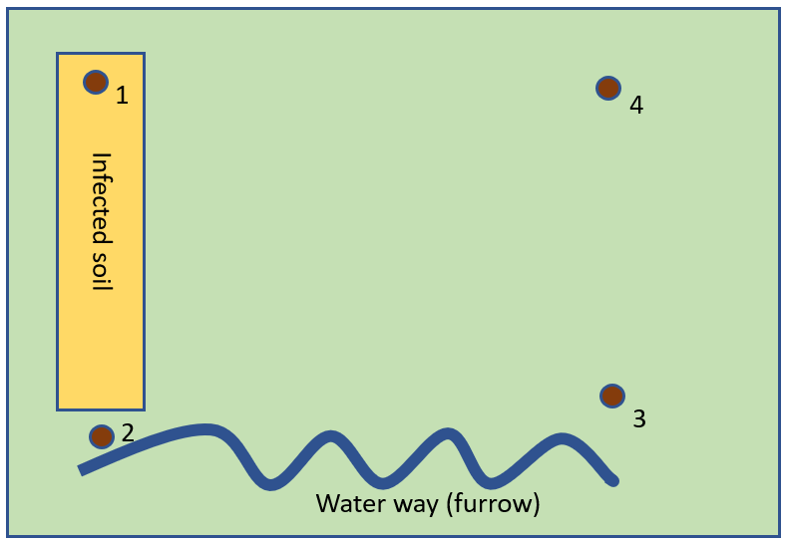

Materials:

* 4x2= 8 100 cm3 pF-rings + caps for bulk density and soil moisture content
* Hammering head
* hammer
* Small spade
* Mini soil auger
* Soil collection bags for texture analysis, pH and organic matter content

#### Taking a bulk density ring sample

• insert a 100 cm3 bulk density ring into the hammering head (see figures to the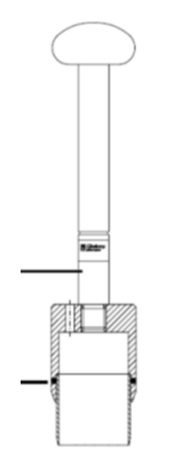

right)

• push into the soil until the engraved line on the outside of the hammering head

is a few mm into the soil

- push in a straight line down (do not wiggle)

- use a hammer if needed

• excavate the ring + hammering head by using a small spade

• dig deep enough to ensure not to loose soil from the ring

• cut excess soil from the ring by using a knife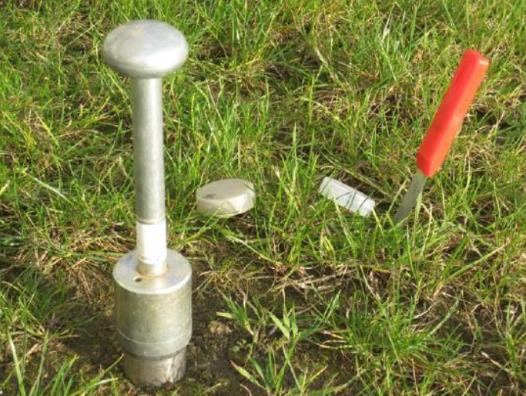

• place a plastic cap

• take the ring out of the hammering head

• cut excess soil from the ring and place the second plastic cap

• close the little pit

#### Taking a composited soil sample

• use a mini-auger

• select 4 points at ~1 m distance from where you took the ring sample: north, east, south, west

• insert the mini-auger to 5 cm soil depth

• rotate once and gently pull out

• empty the auger into a labeled sample bag (you may use a ‘metal’ finger for emptying)

• repeat 3 times (to get a mixed sample based on 4 samplings)

• push air out of the bag and close

For the samples at different depths of the soil, the same soil auger is used in the same manner as for a composited soil sample, repeating it for the three corresponding depths at the four sampling areas in the field. Soil from each depth is collected in different sampling bags.

### Ethics information

### Pilot data

### Design

Exact Methodology:

Neutral criteria and Positive controls:

Experimental Studies: The design is

Add consort checklist:

CONSORT is a protocol developed by a group of researchers not only to identify problems arising from conducting RCTs, but also to report, in a full and clear manner, the results yielded by research, thereby facilitating RCTs reading and quality assessment.

### Sampling Plan

Stats and amount of samples needed

### Analysis Plan

#### DAS-ELISA test (Ava)

DNA extracting/preparing samples

Soil Characterization

Microscope (Gabriela)

PCR and RT-PCR (Mujahid)

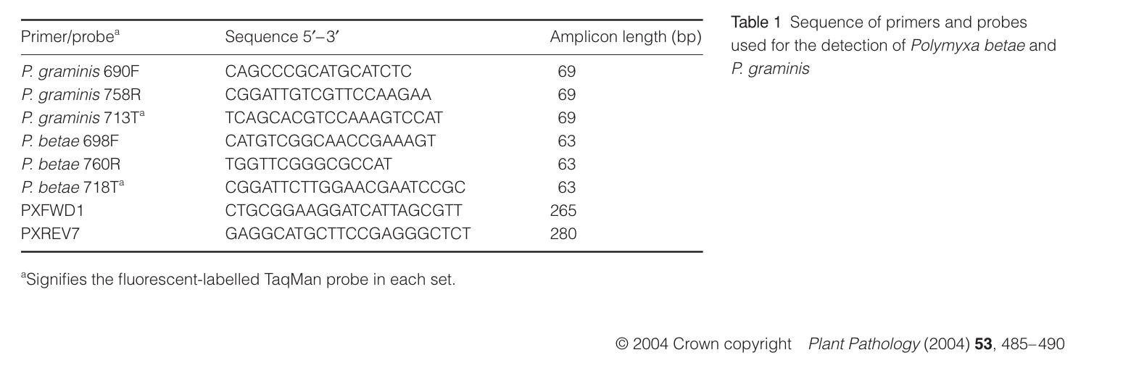

## Results

Do **not** include a **Results** section.

## Discussion

Do **not** include a **Discussion** section.

## References (Ava)

## 

## Acknowledgements

This study was supported by Institut SupAgro in Montpellier, France. We thank this institution for providing consumables as well as laboratory facilities for experimentation. *The funders had a role in study analysis, especially soil characterization. We also thank Véronique Marie-Jeanne, Jacques David, and Sylvain Santoni for sharing your expertise.

## Author contributions

Each author has contributed equally in each step of the conception, experimental design, analysis of results, and writing throughout the process of this experiment.

## Competing interests

The authors declare that they have no conflicts of interest.

## Figures



**Figure 1.**

## Figure Legends

**Figure 1.** Drawing of the sampling site. The locations within the site where we will be taking samples, along with a drawing of the overall features seen on the site itself.

## Table 1. Design Table

| **Question** | **Hypothesis (if applicable)** | **Sampling plan (e.g. power analysis)** | **Analysis Plan** | **Interpretation given to different outcomes** |
| --- | --- | --- | --- | --- |
| How to detect *P. graminis* in soil? |  | ELISA  PCR and RT-PCR |  |  |
|  |  |  |  |  |
|  |  |  |  |  |

## Supplementary Information

Please report pilot data in detail here and include any other material that provides background information.